EXPERIMENT 8
Storyboard Design for Doctor Appointment Booking Application using Balsamiq
AIM:
To design a storyboard representing the user flow of a doctor appointment booking mobile application using Balsamiq.
OBJECTIVE:
To create a clean and user-friendly interface that helps users manage medical records, communicate with doctors, and book appointments easily.
PROCEDURE:
- The doctor appointment booking application concept was selected.
- The key screens such as medical records, messages, and upcoming visits were identified.
- A new project was created in Balsamiq Wireframes.
- Multiple mobile screens were added to represent each feature of the application.
- UI components like cards, buttons, icons, and text fields were used to design each screen.
- A consistent color theme and layout were maintained across all screens.
- The screens were arranged properly to represent the overall user interaction and flow.
USER FLOW:
- Medical Records Screen:
This screen displays the user's health data such as vital stats, recent diagnostics, and immunization status in a card-based layout.
- Messages Screen:
This screen allows users to communicate with doctors through chat, enabling quick consultation and support.
- Upcoming Visits Screen:
This screen shows scheduled appointments with doctors, including date, time, and doctor details.
- Doctor Interaction:
Users can view doctor details and interact with them through booking or messaging features.
- Appointment Management:
Users can schedule, view, and manage their appointments easily within the app.
- Confirmation:
The app confirms scheduled visits and provides necessary details for the frame.

FRAMES:
1.Medical Records:
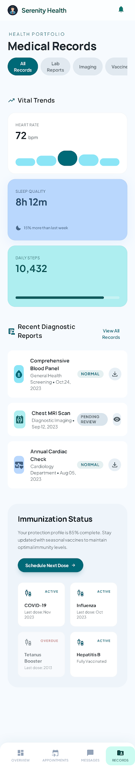

2.Messages:
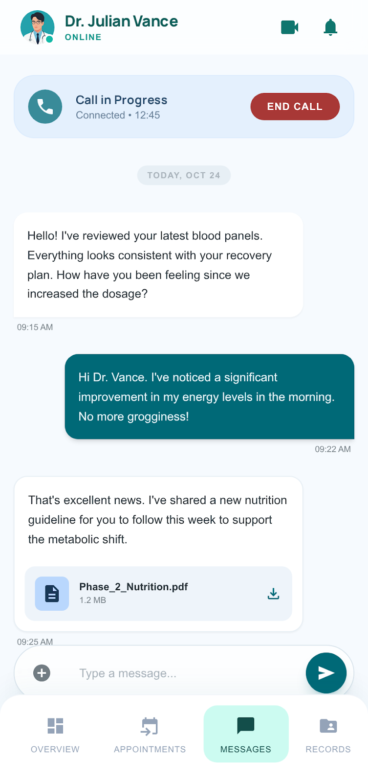

3.Upcoming Appointments:
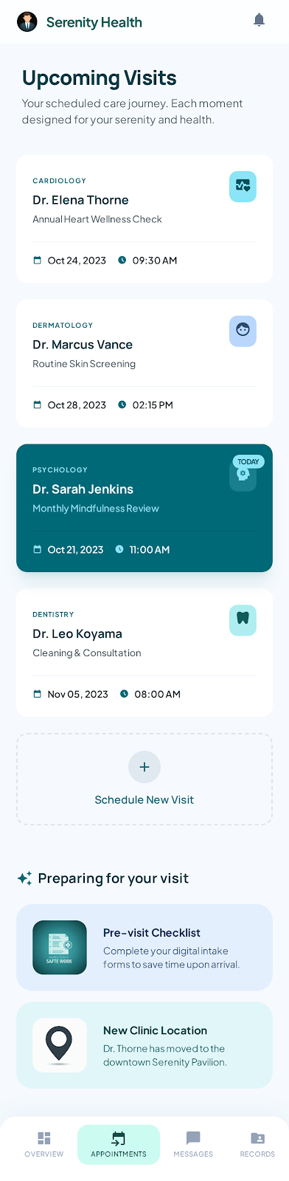
RESULT:

The storyboard was successfully created to represent key features such as medical records management, doctor communication, and appointment scheduling in a healthcare application.

CONCLUSION:

This experiment helped in understanding how modern healthcare applications are designed with user-friendly interfaces. It also showed how wireframes can be used to represent multiple functionalities like records, messaging, and appointments in a structured way.

